**Experiment:4 &9**

1. The user enters two numbers in the text fields, Num1 and Num2. If Num2 was Zero, the program would throw an Arithmetic Exception and handle the exception by displaying it to the user.

**Coding:**

<!DOCTYPE html>

<html lang="en">

<head>

    <meta charset="UTF-8">

    <meta http-equiv="X-UA-Compatible" content="IE=edge">

    <meta name="viewport" content="width=device-width, initial-scale=1.0">

    <title>Document</title>

</head>

<body>

    <table>

         <form>

             <tr>

                 <td>Number 1</td>

                 <td><input type="text" id="number1"></td>

            </tr>

            <tr>

                <td>Number 2</td>

                <td><input type="text" id="number2"></td>

            </tr>

            <tr>

                <td><input type="submit" onclick="add()"></td>

            </tr>

        </form>

    </table>

</body>

<script type="text/javascript">

function add()

{

    try

    {   let n1 = document.getElementById("number1").value;

        let n2 = document.getElementById("number2").value;

        let v1 = parseInt(n1);

        let v2 = parseInt(n2);

        if(v2 == 0)

        {

         throw("Exception Occurs");

        }

        else

        {

         alert(v1+" + "+v2+" = "+(v1+v2));

        }

    }

    catch(e)

    {

        alert("Error: "+e);

    }

}

</script>

</html>

**Output Screenshot:**

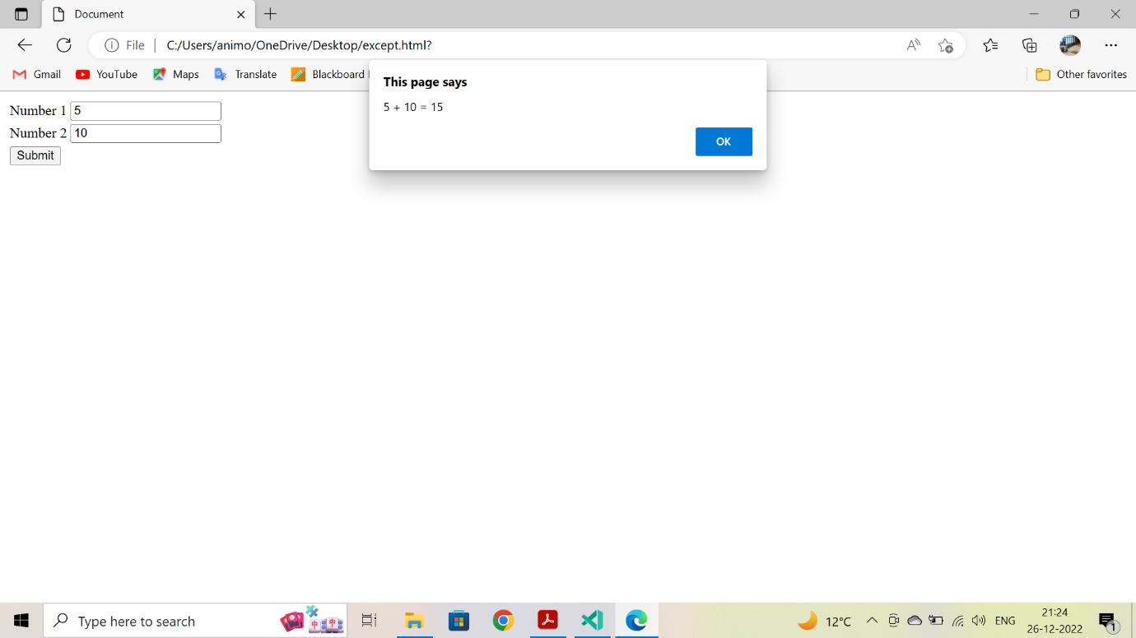

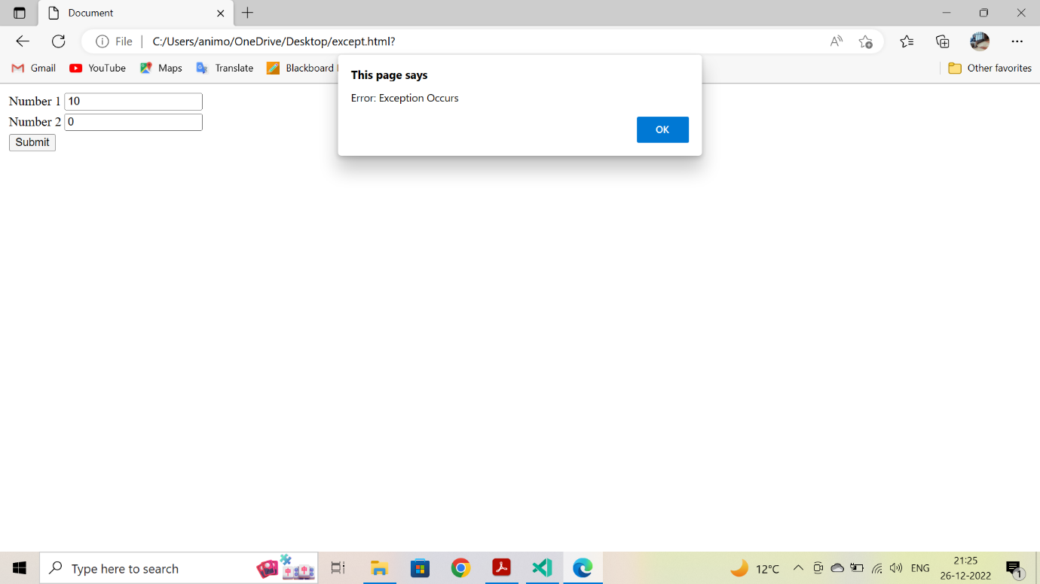

1. WAP to get an employee's name and age and display it with the below condition satisfied.

* If an employee's name is a number, a name exception must be thrown.
* If an employee's age is greater than 50, an age exception must be thrown.
* Or else an object must be created In the case of PHP for the entered employee details and display the details. Note: In JS no need of object creation just display the data.

**Coding:**

<!DOCTYPE html>

<html lang="en">

<head>

    <meta charset="UTF-8">

    <meta http-equiv="X-UA-Compatible" content="IE=edge">

    <meta name="viewport" content="width=device-width, initial-scale=1.0">

    <title>Document</title>

</head>

<body>

<table>

    <form method="POST" action="#">

        <tr>

            <td> Name: </td>

            <td> <input type ="text" name = "name" placeholder="Name"> </td>

        </tr>

        <tr>

            <td> Age: </td>

            <td> <input type ="text" name = "age" placeholder="age"> </td>

        </tr>

        <tr>

            <td> <input type = "submit" name="submit" value="Enter Record">

            </td>

        </tr>

    </form>

</table>

</body>

<?php

class employee

    {

        public $name;

        public $age;

        function __construct($n, $a)

        {

            $this->name = $n;

            $this->age = $a;

        }

        function print_emp()

        {

            echo("Employee Name: ".$this->name."\nAge: ".$this->age);

        }

    }

        if(array_key_exists("submit",$_POST))

            {

                validate_input();

            }

        function validate_input()

        {

            try

            {

            $n = $_POST["name"];

            $a = $_POST["age"];

            if(is_numeric($n))

            {

                throw new TypeError("Name type should be string");

            }

            else if($a >= 50)

            {

                throw new Exception("Age cannot be greater than 50");

            }

            else

            {

                $ob = new employee($n, $a);

                $ob->print_emp();

            }

            }

            catch(TypeError $e)

            {

                echo($e->getMessage()."\n");

            }

            catch(Exception $e)

            {

                echo($e->getMessage()."\n");

            }

        }

?>

</html>

**Output Screenshot:**

